Student Name: __________________
Class and Section __________________
Total Points (20 pts) __________________
Due: November 28, 2016 before the class

Project: Displaying sets of connected circles

CSCI 2410 Data Structures and Algorithms
Armstrong State University

Problem Description:

Write a JavaFX application that lets the user create a circle by clicking a mouse in a blank area that is not currently covered by a circle. If two circles are connected, they are displayed using the same color; otherwise, they are not in same color, as shown in the following figure.

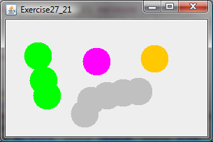

Analysis:
(Describe the problem in your own words)

Design:
(Describe how you use a graph to model this problem)

Coding:
(Only print the applet program here. Don’t print Graph, AbstractGraph, and UnweightedGraph. They are in the text.)

Screen Shots:

What to submit?

1. Email a hard copy of this document.

2. Compile and Submit to LiveLab (you must submit the program regardless whether it complete or incomplete, correct or incorrect. Put all code in one file to submit a compliable file)

3. Fill in self-evaluation:

- Does your program add vertices to the graph correctly? ________
- Does your program add edges to the graph correctly? ________
- Does your program finds connected components correctly? ________
- Does your program display the connected circles in the same color? ________
- Does your program display the circles in different connected components in different colors? ________

